Attachment 1: CVR Equipment Inventory Adjustments

Section 1: Current Inventory Summary
A. CVR Equipment | B. Condition:  G=good  D=damaged  L=lost  NA= the item had previously been damaged or lost but not replaced | C. Identifying #  (Asset tag, or serial # if untagged) | D. Verification of hard drive disposal  (If the Dell Optiplex has been previously disposed, note the method of disposal below and the person/organization responsible for carrying out the disposal)
Dell Optiplex GX 280 CPU
Dell 17-inch flat-screen monitor
Dell 1700NN laser printer
DYMO Label Writer 400
Fujitsu Scanpartner FI-4220C2 flatbed scanner
Wasp bar code scanner WLP-4170

Section 2: Property Transfer Form (Acceptance of Donation from State)
The Municipality of _____________________________ accepts donation of the items listed above.
Action authorized by: ______________________________ Date: ___________ Phone: __________________
Questions concerning responsible disposal of equipment can be referred to CEC.

Section 3: Dell Optiplex Computer Hard Drive Removal

Below are step by step instructions to walk you through the process of removing the hard drive from the Dell Optiplex computer. This computer was provided to all municipalities for use with CVR and was paid for federal funds via the Help America Vote Act of 2002 (HAVA).

Step 1. Turn the computer’s power off. Push the power button and hold it for ten seconds.  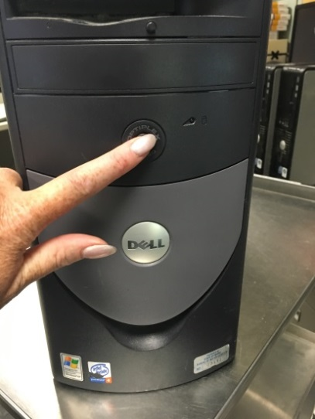 | Step 2. Unplug the power cord from the back of the computer:  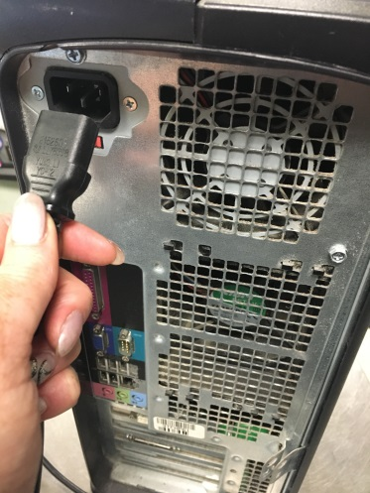
Step 3. Lay the computer on its side with metal grates on top as shown in the image below: | The next two steps are easier with two people. There are two (2) release buttons located on each side of the computer.

Step 4. Press both release buttons at the same time. With two people working on this, one person can hold and press while the other pulls up on the computer case (the side now facing up) to open the case and expose the hard drive.  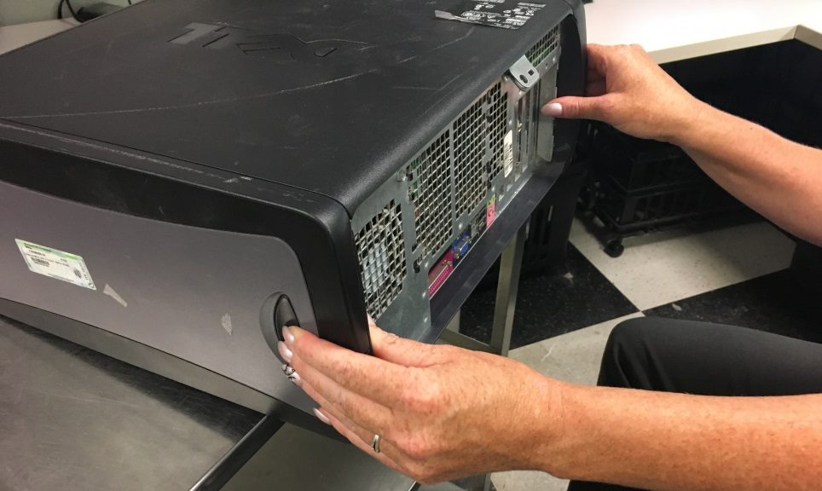 | Step 5. If working alone, press the release buttons and push up with your thumbs to open the case.  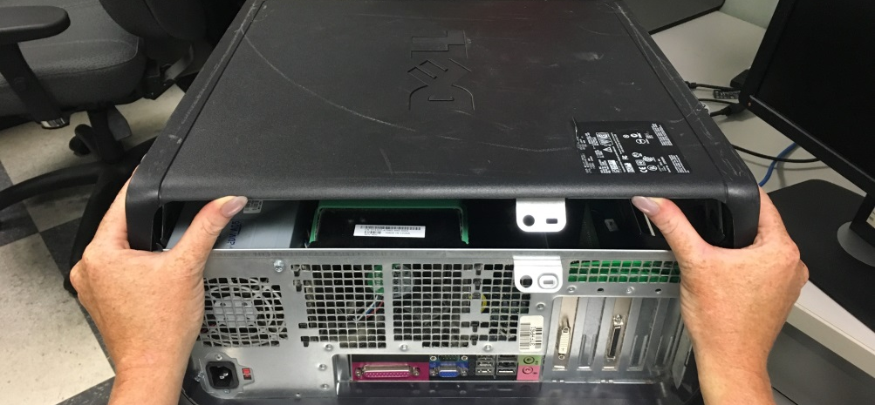
Step 6. Once you open the top as wide as it will go, locate the Hard Drive. It is attached to the part of the case that you have just lifted open. You will see a blue wire and a combination of red, orange and black wires attached to the Hard Drive.  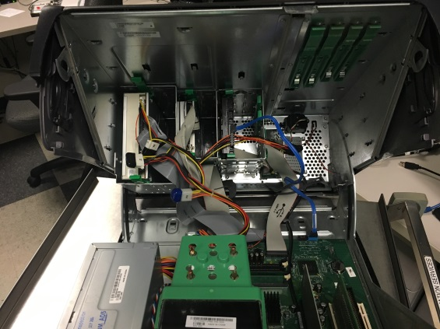 | Step 7. There will be 2 green release tabs on the top and bottom of the Hard Drive, squeeze them towards each other and pull out.
Step 8. Slide hard drive out of the mounted bracket. But be careful, it will still be attached by wires.  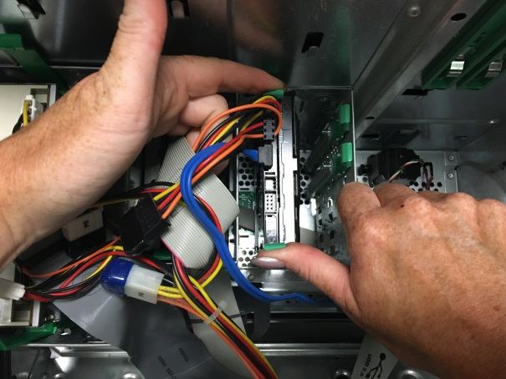 | Step 9. While holding the Hard Drive in one hand, grasp the red, orange, black wires as close to the Hard Drive as you can and apply enough pressure to remove the black connector from the Hard Drive. This might require a little force as the two components can stick. But it should not be too hard to separate them.  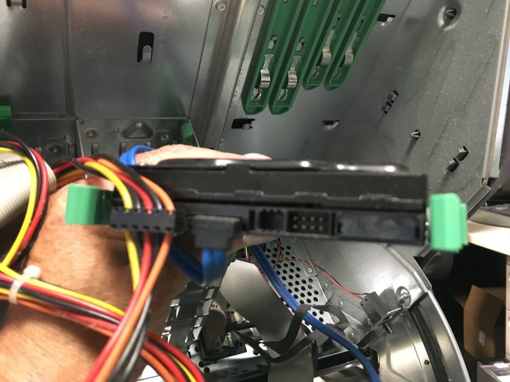  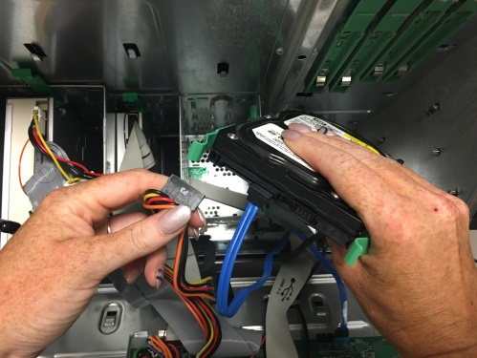

Step10. While holding the Hard Drive in one hand, grasp the blue wire as close to the Hard Drive as you can and apply enough pressure to remove the black connector from the Hard Drive.  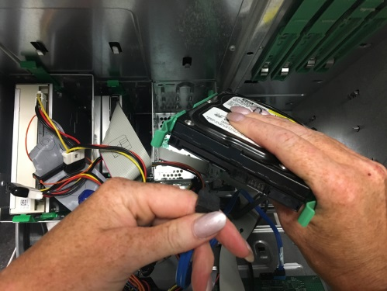  You have successfully removed the Hard Drive.  You may now close the lid to the computer by placing both hands on top and pressing down. You will hear the lid “snap” closed. | Step 11. Mail the hard drive to:  Heidi Peckham, Assistant Director of Elections  Elections Division  Bureau of Corporations, Elections & Commissions  101 State House Station  Augusta, ME 04333-0101  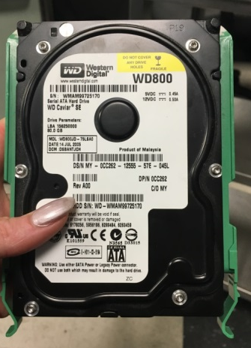  Thank you for your assistance.

